DATABASE MANAGEMENT SYSTEM PROJECT



PROJECT: INVENTORY MANAGEMENT

# BY:

1.Abhinav Bolla (23csb0b03)

2.Rohith krishna(23csb0a22)

# PROBLEM STATEMENT:

Project purpose:

In inventory management, "inventory" refers to the goods and materials that a business holds for the purpose of resale or use in its operations. These items can include raw materials, work-in-progress , and finished goods ready for sale. Inventory is a crucial aspect of operations for many businesses, as it represents a significant portion of their assets and ties up capital. the goal of inventory management is to ensure that a business has the right amount of inventory on hand at the right time to meet customer needs, without incurring unnecessary costs or tying up excessive capital in inventory.

Project Scope:

The scope of this project includes designing and implementing a database schema to store information about inventory items, including their names, quantities, prices, and suppliers. The system will allow users to add, update, delete, and search for inventory items.

# ASSUMPTIONS:

SUPPLIER TABLE:

The Suppliers table serves as a repository for supplier information. Each supplier is uniquely identified by a Supplier_ID, which acts as the primary key. Attributes such as Name, email_id and phone_number are stored to provide comprehensive supplier details.

RAW MATERIALS:

The RawMaterials table contains information about the raw materials supplied by the vendors. Each raw material is identified by a Material_ID, which serves as the primary key. Details such as Description, Unit_Price, Quantity, and the Supplier_ID (foreign key) referencing the Suppliers table are stored to track the characteristics and availability of raw materials.

STORAGE:

The Storage table stores data regarding the storage facilities used to house inventory items. Each storage location is uniquely identified by a Storage_ID, serving as the primary key. Attributes like Location, Capacity, and Type provide essential details about each storage facility.

INVENTORY:

The Inventory table plays a crucial role in tracking the inventory of items stored in various storage locations. Each inventory item is identified by an Inventory_ID, which serves as the primary key. Foreign keys such as Item_ID (referencing the Items table) and Storage_ID (referencing the Storage table) establish relationships with other tables. The Quantity attribute indicates the quantity of each item available in inventory.

ITEMS:

The Items table contains information about the different items available in the inventory. Each item is uniquely identified by an Item_ID, serving as the primary key. Attributes like Name, Description, and Category provide descriptive details about each item.

ORDER:

The Order table is responsible for managing customer orders placed with suppliers. Each order is identified by an Order_ID, serving as the primary key. Attributes such as Date and Total_Price track order-related information, while the Supplier_ID (foreign key) establishes the relationship with the Suppliers table.

SHIPMENT:

The Shipment table stores data about shipments of goods from suppliers to customers or between different locations. Each shipment is identified by a Shipment_ID, serving as the primary key. Details such as Date, Transport_Method, and Destination provide essential information about each shipment.

SHIPMENT_ITEM:

The Shipment_Item table facilitates the tracking of individual items within shipments. Each shipment item is identified by a Shipment_Item_ID, serving as the primary key. Foreign keys such as

Shipment_ID (referencing the Shipment table) and Inventory_ID (referencing the Inventory table) establish relationships with other tables. The Quantity attribute indicates the quantity of each item included in the shipment.

ENTITY RELATIONSHIP DIAGRAM :

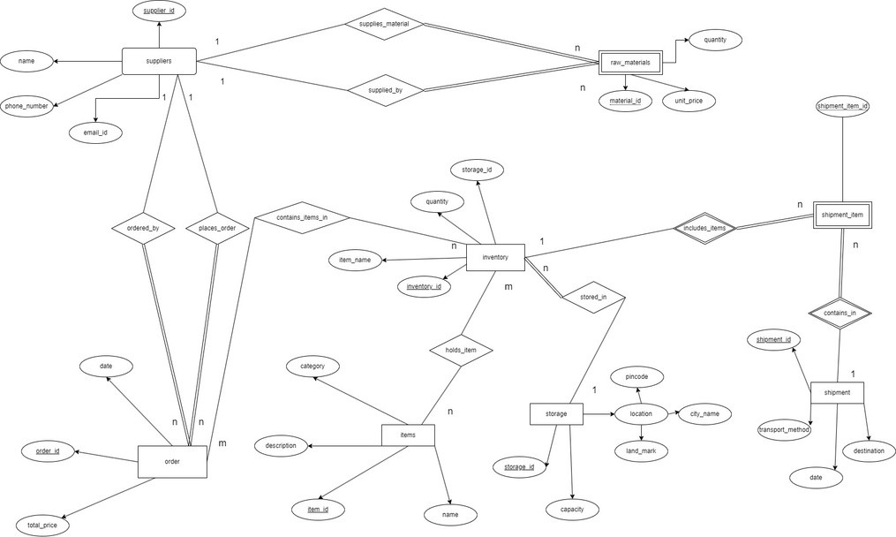

# RELATIONAL SCHEMA:

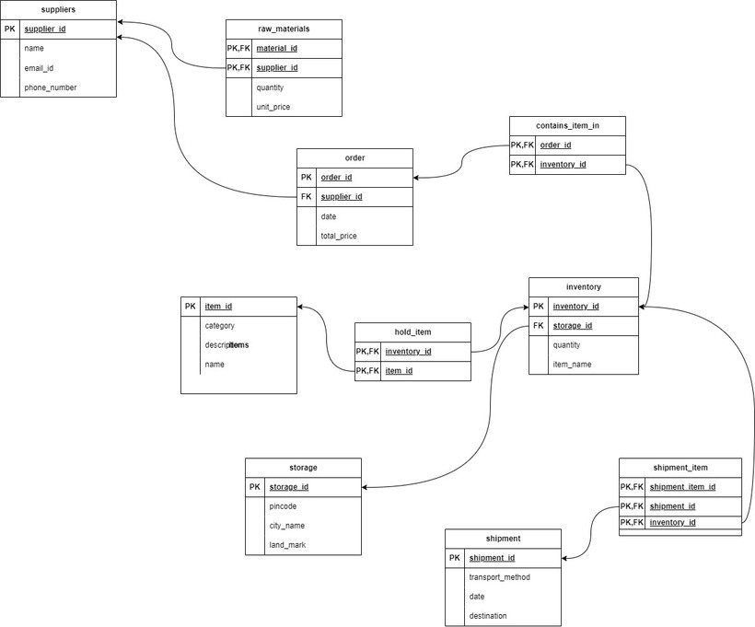

## FUNCTIONAL DEPENDENCIES AND TABLES BEFORE NORMALIZATION:

1. Suppliers:

(Supplier_ID ,Name, email_id,phone_number)

Functional Dependency: Supplier_ID → Name, Address, Contact_Info Normal Form: BCNF

1. RawMaterials:

(Material_ID,Description, Unit_Price, Quantity,Supplier_ID)

Functional Dependency: Material_ID → Description, Unit_Price, Quantity, Supplier_ID

Normal Form: BCNF

1. Storage:

(Storage_ID,Location, Capacity, Type)

Functional Dependency: Storage_ID → Location, Capacity, Type Normal Form: BCNF

1. Inventory:

(Inventory_ID,Item_ID, Quantity, Storage_ID)

Functional Dependency: Inventory_ID → Item_ID, Quantity, Storage_ID Normal Form: BCNF

1. Items:

(Item_ID , Name, Description, Category)

Functional Dependency: Item_ID → Name, Description, Category Normal Form: BCNF

1. Order:

(Order_ID ,Date, Total_Price, Supplier_ID)

Functional Dependency: Order_ID → Date, Total_Price, Supplier_ID Normal Form: BCNF

1. Shipment_Item:

(Shipment_Item_ID,Shipment_ID,Inventory_ID,Quantity,Date,Transport_Metho d,Destination,Order_ID)

Functional Dependency:

Shipment_Item_ID → Shipment_ID, Inventory_ID, Quantity Shipment_ID → Date, Transport_Method, Destination, Order_ID Normal Form:3nf (not in BCNF)

Here, we can observe a violation of BCNF because attributes like Date, Transport_Method, Destination, and Order_ID are not fully functionally dependent on the primary key Shipment_Item_ID. These attributes are only dependent on Shipment_ID.

# FUNCTIONALDEPENDENCIESANDTABLES AFTER NORMALIZATION

1. Suppliers:

(Supplier_ID ,Name, email_id,phone_number)

Functional Dependency: Supplier_ID → Name, Address, Contact_Info Normal Form: BCNF

1. RawMaterials:

(Material_ID,Description, Unit_Price, Quantity,Supplier_ID)

Functional Dependency: Material_ID → Description, Unit_Price, Quantity, Supplier_ID

Normal Form: BCNF

1. Storage:

(Storage_ID,Location, Capacity, Type)

Functional Dependency: Storage_ID → Location, Capacity, Type Normal Form: BCNF

1. Inventory:

(Inventory_ID,Item_ID, Quantity, Storage_ID)

Functional Dependency: Inventory_ID → Item_ID, Quantity, Storage_ID Normal Form: BCNF

1. Items:

(Item_ID , Name, Description, Category)

Functional Dependency: Item_ID → Name, Description, Category Normal Form: BCNF

1. Order:

(Order_ID ,Date, Total_Price, Supplier_ID)

Functional Dependency: Order_ID → Date, Total_Price, Supplier_ID Normal Form: BCNF

1. Shipment_Item:

after normalization table decomposes into shipment_item,shipment shipment:

(Shipment_ID , Date, Transport_Method, Destination, Order_ID)

Functional Dependency:

Shipment_ID → Date, Transport_Method, Destination, Order_ID Normal Form:BCNF

1. shipment_item:

(Shipment_Item_ID , Shipment_ID, Inventory_ID, Quantity) Functional Dependency:

Shipment_Item_ID → Shipment_ID, Inventory_ID, Quantity Normal Form:BCNF

create table suppliers ( supplier_id int primary key, name varchar(20),

email varchar(20), phone_no int

);

create table raw_materials ( material_id int not null, unit_price int,

quantity int, supplier_id int,

primary key(material_id, supplier_id),

constraint fk_supplier_id foreign key(supplier_id) references suppliers(supplier_id)

);

create table orders(

order_id int primary key, order_date date, total_price int, suppliers_id int,

constraint fk_suppliers_id foreign key(suppliers_id) references suppliers(supplier_id)

);

create table storage ( storage_id int primary key, pincode int,

land_mark varchar(20), city_name varchar(20)

);

create table inventory( inventory_id int primary key, item_name varchar(20), quantity int,

storage_id int,

constraint fk_storage_id foreign key(storage_id) references storage(storage_id)

);

create table hold_item ( invento_id int, item_id int,

primary key(invento_id, item_id),

constraint fk_item_id foreign key(item_id) references items(item_id), constraint fk_invento_id foreign key(invento_id) references

inventory(inventory_id)

);

create table items ( item_id int primary key, description varchar(20), category varchar(20), name varchar(20)

);

create table hold_item ( inventory_id int, item_id int,

primary key(inventory_id, item_id),

constraint fk_item_id foreign key(item_id) references items(item_id), constraint fk_inventory_id foreign key(inventory_id) references

inventory(inventory_id)

);

create table shipment( shipment_id int primary key, ship_date date, transport_method varchar(50), destination varchar(50)

);

create table shipment_item( shipment_item_id int not null, invent_id int,

shipment_id int,

primary key(shipment_item_id, invent_id, shipment_id), constraint fk_invent_id foreign key(invent_id) references

inventory(inventory_id),

constraint fk_shipment_id foreign key(shipment_id) references shipment(shipment_id)

);

INSERT INTO suppliers (supplier_id, name, email, phone_no) VALUES (1, 'Supplier A1', ['a1@example.com',](mailto:%27a1@example.com) 1000000001);

INSERT INTO suppliers (supplier_id, name, email, phone_no) VALUES

(2, 'Supplier A2', ['a2@example.com',](mailto:%27a2@example.com) 1000000002);

INSERT INTO suppliers (supplier_id, name, email, phone_no) VALUES

(3, 'Supplier A3', ['a3@example.com',](mailto:%27a3@example.com) 1000000003);

INSERT INTO suppliers (supplier_id, name, email, phone_no) VALUES (4, 'Supplier A4', ['a4@example.com',](mailto:%27a4@example.com) 1000000004);

INSERT INTO suppliers (supplier_id, name, email, phone_no) VALUES

(5, 'Supplier A5', ['a5@example.com',](mailto:%27a5@example.com) 1000000005);

INSERT INTO suppliers (supplier_id, name, email, phone_no) VALUES (6, 'Supplier A6', ['a6@example.com',](mailto:%27a6@example.com) 1000000006);

INSERT INTO suppliers (supplier_id, name, email, phone_no) VALUES (7, 'Supplier A7', ['a7@example.com',](mailto:%27a7@example.com) 1000000007);

INSERT INTO suppliers (supplier_id, name, email, phone_no) VALUES (8, 'Supplier A8', ['a8@example.com',](mailto:%27a8@example.com) 1000000008);

INSERT INTO suppliers (supplier_id, name, email, phone_no) VALUES (9, 'Supplier A9', ['a9@example.com',](mailto:%27a9@example.com) 1000000009);

INSERT INTO suppliers (supplier_id, name, email, phone_no) VALUES

(10, 'Supplier A10', ['a10@example.com',](mailto:%27a10@example.com) 1000000010);

INSERT INTO suppliers (supplier_id, name, email, phone_no) VALUES (11, 'Supplier B1', ['b1@example.com',](mailto:%27b1@example.com) 1000000011);

INSERT INTO suppliers (supplier_id, name, email, phone_no) VALUES (12, 'Supplier B2', ['b2@example.com',](mailto:%27b2@example.com) 1000000012);

INSERT INTO suppliers (supplier_id, name, email, phone_no) VALUES (13, 'Supplier B3', ['b3@example.com',](mailto:%27b3@example.com) 1000000013);

INSERT INTO suppliers (supplier_id, name, email, phone_no) VALUES

(14, 'Supplier B4', ['b4@example.com',](mailto:%27b4@example.com) 1000000014);

INSERT INTO suppliers (supplier_id, name, email, phone_no) VALUES (15, 'Supplier B5', ['b5@example.com',](mailto:%27b5@example.com) 1000000015);

INSERT INTO suppliers (supplier_id, name, email, phone_no) VALUES (16, 'Supplier B6', ['b6@example.com',](mailto:%27b6@example.com) 1000000016);

INSERT INTO suppliers (supplier_id, name, email, phone_no) VALUES (17, 'Supplier B7', ['b7@example.com',](mailto:%27b7@example.com) 1000000017);

INSERT INTO suppliers (supplier_id, name, email, phone_no) VALUES (18, 'Supplier B8', ['b8@example.com',](mailto:%27b8@example.com) 1000000018);

INSERT INTO suppliers (supplier_id, name, email, phone_no) VALUES

(19, 'Supplier B9', ['b9@example.com',](mailto:%27b9@example.com) 1000000019);

INSERT INTO suppliers (supplier_id, name, email, phone_no) VALUES (20, 'Supplier B10', ['b10@example.com',](mailto:%27b10@example.com) 1000000020);

INSERT INTO suppliers (supplier_id, name, email, phone_no) VALUES (21, 'Supplier C1', ['c1@example.com',](mailto:%27c1@example.com) 1000000021);

INSERT INTO suppliers (supplier_id, name, email, phone_no) VALUES (22, 'Supplier C2', ['c2@example.com',](mailto:%27c2@example.com) 1000000022);

INSERT INTO suppliers (supplier_id, name, email, phone_no) VALUES

(23, 'Supplier C3', ['c3@example.com',](mailto:%27c3@example.com) 1000000023);

INSERT INTO suppliers (supplier_id, name, email, phone_no) VALUES (24, 'Supplier C4', ['c4@example.com',](mailto:%27c4@example.com) 1000000024);

INSERT INTO suppliers (supplier_id, name, email, phone_no) VALUES (25, 'Supplier C5', ['c5@example.com',](mailto:%27c5@example.com) 1000000025);

INSERT INTO suppliers (supplier_id, name, email, phone_no) VALUES

(26, 'Supplier C6', ['c6@example.com',](mailto:%27c6@example.com) 1000000026);

INSERT INTO suppliers (supplier_id, name, email, phone_no) VALUES (27, 'Supplier C7', ['c7@example.com',](mailto:%27c7@example.com) 1000000027);

INSERT INTO suppliers (supplier_id, name, email, phone_no) VALUES

(28, 'Supplier C8', ['c8@example.com',](mailto:%27c8@example.com) 1000000028);

INSERT INTO suppliers (supplier_id, name, email, phone_no) VALUES (29, 'Supplier C9', ['c9@example.com',](mailto:%27c9@example.com) 1000000029);

INSERT INTO suppliers (supplier_id, name, email, phone_no) VALUES (30, 'Supplier C10', ['c10@example.com',](mailto:%27c10@example.com) 1000000030);

select * from suppliers;

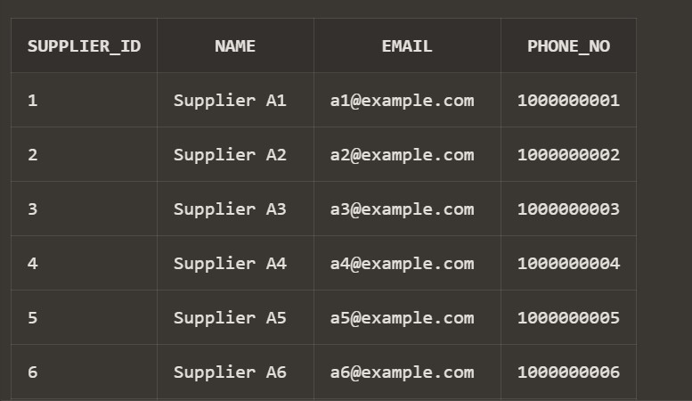

INSERT INTO raw_materials (material_id, unit_price, quantity, supplier_id) VALUES

(1, 105, 22, 1);

INSERT INTO raw_materials (material_id, unit_price, quantity, supplier_id) VALUES

(31, 102, 2, 1);

INSERT INTO raw_materials (material_id, unit_price, quantity, supplier_id) VALUES

(32, 10, 12, 1);

INSERT INTO raw_materials (material_id, unit_price, quantity, supplier_id) VALUES

(33, 100, 22, 1);

INSERT INTO raw_materials (material_id, unit_price, quantity, supplier_id) VALUES

(2, 110, 24, 2);

INSERT INTO raw_materials (material_id, unit_price, quantity, supplier_id) VALUES

(3, 115, 26, 3);

INSERT INTO raw_materials (material_id, unit_price, quantity, supplier_id) VALUES

(4, 120, 28, 4);

INSERT INTO raw_materials (material_id, unit_price, quantity, supplier_id) VALUES

(5, 125, 30, 5);

INSERT INTO raw_materials (material_id, unit_price, quantity, supplier_id) VALUES

(6, 130, 32, 6);

INSERT INTO raw_materials (material_id, unit_price, quantity, supplier_id) VALUES

(7, 135, 34, 7);

INSERT INTO raw_materials (material_id, unit_price, quantity, supplier_id) VALUES

(8, 140, 36, 8);

INSERT INTO raw_materials (material_id, unit_price, quantity, supplier_id) VALUES

(9, 145, 38, 9);

INSERT INTO raw_materials (material_id, unit_price, quantity, supplier_id) VALUES

(10, 150, 40, 10);

INSERT INTO raw_materials (material_id, unit_price, quantity, supplier_id) VALUES

(11, 155, 42, 11);

INSERT INTO raw_materials (material_id, unit_price, quantity, supplier_id) VALUES

(12, 160, 44, 12);

INSERT INTO raw_materials (material_id, unit_price, quantity, supplier_id) VALUES

(13, 165, 46, 13);

INSERT INTO raw_materials (material_id, unit_price, quantity, supplier_id) VALUES

(14, 170, 48, 14);

INSERT INTO raw_materials (material_id, unit_price, quantity, supplier_id) VALUES

(15, 175, 50, 15);

INSERT INTO raw_materials (material_id, unit_price, quantity, supplier_id) VALUES

(16, 180, 52, 16);

INSERT INTO raw_materials (material_id, unit_price, quantity, supplier_id)

VALUES

(17, 185, 54, 17);

INSERT INTO raw_materials (material_id, unit_price, quantity, supplier_id) VALUES

(18, 190, 56, 18);

INSERT INTO raw_materials (material_id, unit_price, quantity, supplier_id) VALUES

(19, 195, 58, 19);

INSERT INTO raw_materials (material_id, unit_price, quantity, supplier_id) VALUES

(20, 200, 60, 20);

INSERT INTO raw_materials (material_id, unit_price, quantity, supplier_id) VALUES

(21, 205, 62, 21);

INSERT INTO raw_materials (material_id, unit_price, quantity, supplier_id) VALUES

(22, 210, 64, 22);

INSERT INTO raw_materials (material_id, unit_price, quantity, supplier_id) VALUES

(23, 215, 66, 23);

INSERT INTO raw_materials (material_id, unit_price, quantity, supplier_id) VALUES

(24, 220, 68, 24);

INSERT INTO raw_materials (material_id, unit_price, quantity, supplier_id) VALUES

(25, 225, 70, 25);

INSERT INTO raw_materials (material_id, unit_price, quantity, supplier_id) VALUES

(26, 230, 72, 26);

INSERT INTO raw_materials (material_id, unit_price, quantity, supplier_id) VALUES

(27, 235, 74, 27);

INSERT INTO raw_materials (material_id, unit_price, quantity, supplier_id) VALUES

(28, 240, 76, 28);

INSERT INTO raw_materials (material_id, unit_price, quantity, supplier_id) VALUES

(29, 245, 78, 29);

INSERT INTO raw_materials (material_id, unit_price, quantity, supplier_id) VALUES

(30, 250, 80, 30);

select * from raw_materials;

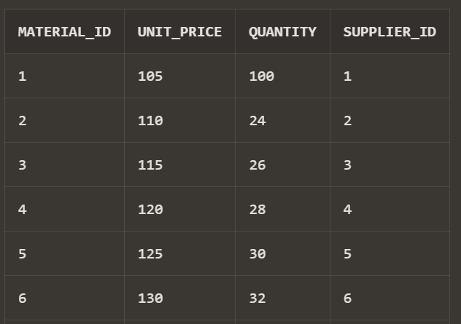

INSERT INTO storage (storage_id, pincode, land_mark, city_name) VALUES (1, 110001, 'Landmark 1', 'City 2');

INSERT INTO storage (storage_id, pincode, land_mark, city_name) VALUES (2, 110002, 'Landmark 2', 'City 3');

INSERT INTO storage (storage_id, pincode, land_mark, city_name) VALUES (3, 110003, 'Landmark 3', 'City 4');

INSERT INTO storage (storage_id, pincode, land_mark, city_name) VALUES (4, 110004, 'Landmark 4', 'City 5');

INSERT INTO storage (storage_id, pincode, land_mark, city_name) VALUES

(5, 110005, 'Landmark 5', 'City 1');

INSERT INTO storage (storage_id, pincode, land_mark, city_name) VALUES (6, 110006, 'Landmark 6', 'City 2');

INSERT INTO storage (storage_id, pincode, land_mark, city_name) VALUES (7, 110007, 'Landmark 7', 'City 3');

INSERT INTO storage (storage_id, pincode, land_mark, city_name) VALUES (8, 110008, 'Landmark 8', 'City 4');

INSERT INTO storage (storage_id, pincode, land_mark, city_name) VALUES

(9, 110009, 'Landmark 9', 'City 5');

INSERT INTO storage (storage_id, pincode, land_mark, city_name) VALUES (10, 110010, 'Landmark 10', 'City 1');

INSERT INTO storage (storage_id, pincode, land_mark, city_name) VALUES (11, 110011, 'Landmark 11', 'City 2');

INSERT INTO storage (storage_id, pincode, land_mark, city_name) VALUES

(12, 110012, 'Landmark 12', 'City 3');

INSERT INTO storage (storage_id, pincode, land_mark, city_name) VALUES (13, 110013, 'Landmark 13', 'City 4');

INSERT INTO storage (storage_id, pincode, land_mark, city_name) VALUES

(14, 110014, 'Landmark 14', 'City 5');

INSERT INTO storage (storage_id, pincode, land_mark, city_name) VALUES (15, 110015, 'Landmark 15', 'City 1');

INSERT INTO storage (storage_id, pincode, land_mark, city_name) VALUES (16, 110016, 'Landmark 16', 'City 2');

INSERT INTO storage (storage_id, pincode, land_mark, city_name) VALUES (17, 110017, 'Landmark 17', 'City 3');

INSERT INTO storage (storage_id, pincode, land_mark, city_name) VALUES (18, 110018, 'Landmark 18', 'City 4');

INSERT INTO storage (storage_id, pincode, land_mark, city_name) VALUES

(19, 110019, 'Landmark 19', 'City 5');

INSERT INTO storage (storage_id, pincode, land_mark, city_name) VALUES (20, 110020, 'Landmark 20', 'City 1');

INSERT INTO storage (storage_id, pincode, land_mark, city_name) VALUES (21, 110021, 'Landmark 21', 'City 2');

INSERT INTO storage (storage_id, pincode, land_mark, city_name) VALUES (22, 110022, 'Landmark 22', 'City 3');

INSERT INTO storage (storage_id, pincode, land_mark, city_name) VALUES

(23, 110023, 'Landmark 23', 'City 4');

INSERT INTO storage (storage_id, pincode, land_mark, city_name) VALUES (24, 110024, 'Landmark 24', 'City 5');

INSERT INTO storage (storage_id, pincode, land_mark, city_name) VALUES (25, 110025, 'Landmark 25', 'City 1');

INSERT INTO storage (storage_id, pincode, land_mark, city_name) VALUES (26, 110026, 'Landmark 26', 'City 2');

INSERT INTO storage (storage_id, pincode, land_mark, city_name) VALUES (27, 110027, 'Landmark 27', 'City 3');

INSERT INTO storage (storage_id, pincode, land_mark, city_name) VALUES

(28, 110028, 'Landmark 28', 'City 4');

INSERT INTO storage (storage_id, pincode, land_mark, city_name) VALUES (29, 110029, 'Landmark 29', 'City 5');

INSERT INTO storage (storage_id, pincode, land_mark, city_name) VALUES (30, 110030, 'Landmark 30', 'City 1');

select * from storage;

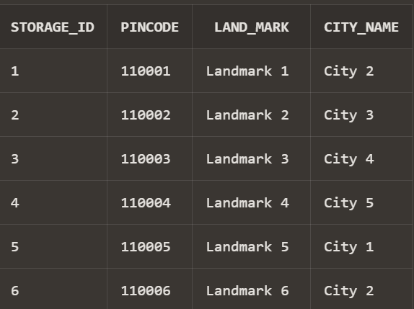

INSERT INTO orders (order_id, order_date, total_price, suppliers_id) VALUES (1, TO_DATE('2023-01-02', 'YYYY-MM-DD'), 515, 1);

INSERT INTO orders (order_id, order_date, total_price, suppliers_id) VALUES (2, TO_DATE('2023-01-03', 'YYYY-MM-DD'), 530, 2);

INSERT INTO orders (order_id, order_date, total_price, suppliers_id) VALUES (3, TO_DATE('2023-01-04', 'YYYY-MM-DD'), 545, 3);

INSERT INTO orders (order_id, order_date, total_price, suppliers_id) VALUES (4, TO_DATE('2023-01-05', 'YYYY-MM-DD'), 560, 4);

INSERT INTO orders (order_id, order_date, total_price, suppliers_id) VALUES (5, TO_DATE('2023-01-06', 'YYYY-MM-DD'), 575, 5);

INSERT INTO orders (order_id, order_date, total_price, suppliers_id) VALUES (6, TO_DATE('2023-01-07', 'YYYY-MM-DD'), 590, 6);

INSERT INTO orders (order_id, order_date, total_price, suppliers_id) VALUES (7, TO_DATE('2023-01-08', 'YYYY-MM-DD'), 605, 7);

INSERT INTO orders (order_id, order_date, total_price, suppliers_id) VALUES (8, TO_DATE('2023-01-09', 'YYYY-MM-DD'), 620, 8);

INSERT INTO orders (order_id, order_date, total_price, suppliers_id) VALUES (9, TO_DATE('2023-01-10', 'YYYY-MM-DD'), 635, 9);

INSERT INTO orders (order_id, order_date, total_price, suppliers_id) VALUES (10, TO_DATE('2023-01-11', 'YYYY-MM-DD'), 650, 10);

INSERT INTO orders (order_id, order_date, total_price, suppliers_id) VALUES (11, TO_DATE('2023-01-12', 'YYYY-MM-DD'), 665, 11);

INSERT INTO orders (order_id, order_date, total_price, suppliers_id) VALUES (12, TO_DATE('2023-01-13', 'YYYY-MM-DD'), 680, 12);

INSERT INTO orders (order_id, order_date, total_price, suppliers_id) VALUES (13, TO_DATE('2023-01-14', 'YYYY-MM-DD'), 695, 13);

INSERT INTO orders (order_id, order_date, total_price, suppliers_id) VALUES (14, TO_DATE('2023-01-15', 'YYYY-MM-DD'), 710, 14);

INSERT INTO orders (order_id, order_date, total_price, suppliers_id) VALUES (15, TO_DATE('2023-01-16', 'YYYY-MM-DD'), 725, 15);

INSERT INTO orders (order_id, order_date, total_price, suppliers_id) VALUES (16, TO_DATE('2023-01-17', 'YYYY-MM-DD'), 740, 16);

INSERT INTO orders (order_id, order_date, total_price, suppliers_id) VALUES (17, TO_DATE('2023-01-18', 'YYYY-MM-DD'), 755, 17);

INSERT INTO orders (order_id, order_date, total_price, suppliers_id) VALUES (18, TO_DATE('2023-01-19', 'YYYY-MM-DD'), 770, 18);

INSERT INTO orders (order_id, order_date, total_price, suppliers_id) VALUES (19, TO_DATE('2023-01-20', 'YYYY-MM-DD'), 785, 19);

INSERT INTO orders (order_id, order_date, total_price, suppliers_id) VALUES (20, TO_DATE('2023-01-21', 'YYYY-MM-DD'), 800, 20);

INSERT INTO orders (order_id, order_date, total_price, suppliers_id) VALUES (21, TO_DATE('2023-01-22', 'YYYY-MM-DD'), 815, 21);

INSERT INTO orders (order_id, order_date, total_price, suppliers_id) VALUES (22, TO_DATE('2023-01-23', 'YYYY-MM-DD'), 830, 22);

INSERT INTO orders (order_id, order_date, total_price, suppliers_id) VALUES (23, TO_DATE('2023-01-24', 'YYYY-MM-DD'), 845, 23);

INSERT INTO orders (order_id, order_date, total_price, suppliers_id) VALUES (24, TO_DATE('2023-01-25', 'YYYY-MM-DD'), 860, 24);

INSERT INTO orders (order_id, order_date, total_price, suppliers_id) VALUES (25, TO_DATE('2023-01-26', 'YYYY-MM-DD'), 875, 25);

INSERT INTO orders (order_id, order_date, total_price, suppliers_id) VALUES (26, TO_DATE('2023-01-27', 'YYYY-MM-DD'), 890, 26);

INSERT INTO orders (order_id, order_date, total_price, suppliers_id) VALUES (27, TO_DATE('2023-01-28', 'YYYY-MM-DD'), 905, 27);

INSERT INTO orders (order_id, order_date, total_price, suppliers_id) VALUES (28, TO_DATE('2023-01-29', 'YYYY-MM-DD'), 920, 28);

INSERT INTO orders (order_id, order_date, total_price, suppliers_id) VALUES (29, TO_DATE('2023-01-30', 'YYYY-MM-DD'), 935, 29);

INSERT INTO orders (order_id, order_date, total_price, suppliers_id) VALUES (30, TO_DATE('2023-01-31', 'YYYY-MM-DD'), 950, 30);

select * from orders;

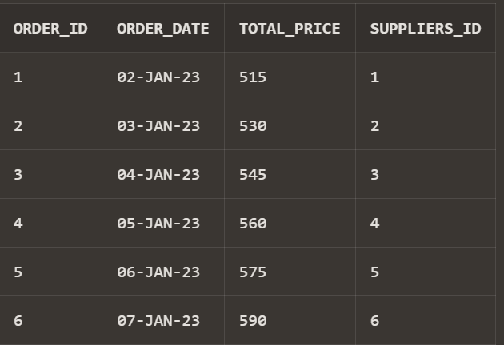

INSERT INTO inventory (inventory_id, item_name, quantity, storage_id) VALUES (1, 'Item 1', 53, 1);

INSERT INTO inventory (inventory_id, item_name, quantity, storage_id) VALUES (2, 'Item 2', 56, 2);

INSERT INTO inventory (inventory_id, item_name, quantity, storage_id) VALUES (3, 'Item 3', 59, 3);

INSERT INTO inventory (inventory_id, item_name, quantity, storage_id) VALUES (4, 'Item 4', 62, 4);

INSERT INTO inventory (inventory_id, item_name, quantity, storage_id) VALUES (5, 'Item 5', 65, 5);

INSERT INTO inventory (inventory_id, item_name, quantity, storage_id) VALUES (6, 'Item 6', 68, 1);

INSERT INTO inventory (inventory_id, item_name, quantity, storage_id) VALUES (7, 'Item 7', 71, 2);

INSERT INTO inventory (inventory_id, item_name, quantity, storage_id) VALUES (8, 'Item 8', 74, 3);

INSERT INTO inventory (inventory_id, item_name, quantity, storage_id) VALUES (9, 'Item 9', 77, 4);

INSERT INTO inventory (inventory_id, item_name, quantity, storage_id) VALUES (10, 'Item 10', 80, 5);

INSERT INTO inventory (inventory_id, item_name, quantity, storage_id) VALUES (11, 'Item 11', 83, 1);

INSERT INTO inventory (inventory_id, item_name, quantity, storage_id) VALUES (12, 'Item 12', 86, 2);

INSERT INTO inventory (inventory_id, item_name, quantity, storage_id) VALUES (13, 'Item 13', 89, 3);

INSERT INTO inventory (inventory_id, item_name, quantity, storage_id) VALUES (14, 'Item 14', 92, 4);

INSERT INTO inventory (inventory_id, item_name, quantity, storage_id) VALUES (15, 'Item 15', 95, 5);

INSERT INTO inventory (inventory_id, item_name, quantity, storage_id) VALUES (16, 'Item 16', 98, 1);

INSERT INTO inventory (inventory_id, item_name, quantity, storage_id) VALUES (17, 'Item 17', 101, 2);

INSERT INTO inventory (inventory_id, item_name, quantity, storage_id) VALUES (18, 'Item 18', 104, 3);

INSERT INTO inventory (inventory_id, item_name, quantity, storage_id) VALUES (19, 'Item 19', 107, 4);

INSERT INTO inventory (inventory_id, item_name, quantity, storage_id) VALUES (20, 'Item 20', 110, 5);

INSERT INTO inventory (inventory_id, item_name, quantity, storage_id) VALUES (21, 'Item 21', 113, 1);

INSERT INTO inventory (inventory_id, item_name, quantity, storage_id) VALUES (22, 'Item 22', 116, 2);

INSERT INTO inventory (inventory_id, item_name, quantity, storage_id) VALUES (23, 'Item 23', 119, 3);

INSERT INTO inventory (inventory_id, item_name, quantity, storage_id) VALUES (24, 'Item 24', 122, 4);

INSERT INTO inventory (inventory_id, item_name, quantity, storage_id) VALUES (25, 'Item 25', 125, 5);

INSERT INTO inventory (inventory_id, item_name, quantity, storage_id) VALUES (26, 'Item 26', 128, 1);

INSERT INTO inventory (inventory_id, item_name, quantity, storage_id) VALUES (27, 'Item 27', 131, 2);

INSERT INTO inventory (inventory_id, item_name, quantity, storage_id) VALUES (28, 'Item 28', 134, 3);

INSERT INTO inventory (inventory_id, item_name, quantity, storage_id) VALUES (29, 'Item 29', 137, 4);

INSERT INTO inventory (inventory_id, item_name, quantity, storage_id) VALUES (30, 'Item 30', 140, 5);

select * from inventory;

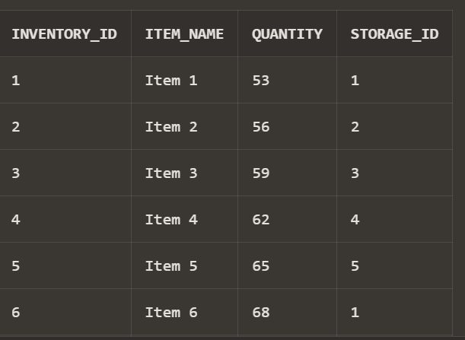

INSERT INTO contains_items_in (orders_id, inventorys_id) VALUES (1, 1); INSERT INTO contains_items_in (orders_id, inventorys_id) VALUES (1, 2); INSERT INTO contains_items_in (orders_id, inventorys_id) VALUES (1, 3); INSERT INTO contains_items_in (orders_id, inventorys_id) VALUES (1, 4); INSERT INTO contains_items_in (orders_id, inventorys_id) VALUES (1, 5); INSERT INTO contains_items_in (orders_id, inventorys_id) VALUES (1, 6); INSERT INTO contains_items_in (orders_id, inventorys_id) VALUES (1, 7); INSERT INTO contains_items_in (orders_id, inventorys_id) VALUES (1, 8); INSERT INTO contains_items_in (orders_id, inventorys_id) VALUES (1, 9); INSERT INTO contains_items_in (orders_id, inventorys_id) VALUES (1, 10); INSERT INTO contains_items_in (orders_id, inventorys_id) VALUES (2, 1); INSERT INTO contains_items_in (orders_id, inventorys_id) VALUES (2, 2); INSERT INTO contains_items_in (orders_id, inventorys_id) VALUES (2, 3); INSERT INTO contains_items_in (orders_id, inventorys_id) VALUES (2, 4); INSERT INTO contains_items_in (orders_id, inventorys_id) VALUES (2, 5);

INSERT INTO contains_items_in (orders_id, inventorys_id) VALUES (2, 6); INSERT INTO contains_items_in (orders_id, inventorys_id) VALUES (2, 7); INSERT INTO contains_items_in (orders_id, inventorys_id) VALUES (2, 8); INSERT INTO contains_items_in (orders_id, inventorys_id) VALUES (2, 9); INSERT INTO contains_items_in (orders_id, inventorys_id) VALUES (2, 20); INSERT INTO contains_items_in (orders_id, inventorys_id) VALUES (3, 1); INSERT INTO contains_items_in (orders_id, inventorys_id) VALUES (3, 2); INSERT INTO contains_items_in (orders_id, inventorys_id) VALUES (3, 3); INSERT INTO contains_items_in (orders_id, inventorys_id) VALUES (3, 4); INSERT INTO contains_items_in (orders_id, inventorys_id) VALUES (3, 5); INSERT INTO contains_items_in (orders_id, inventorys_id) VALUES (3, 6); INSERT INTO contains_items_in (orders_id, inventorys_id) VALUES (3, 7); INSERT INTO contains_items_in (orders_id, inventorys_id) VALUES (3, 8); INSERT INTO contains_items_in (orders_id, inventorys_id) VALUES (3, 9); INSERT INTO contains_items_in (orders_id, inventorys_id) VALUES (3, 30); INSERT INTO contains_items_in (orders_id, inventorys_id) VALUES (4, 1); INSERT INTO contains_items_in (orders_id, inventorys_id) VALUES (4, 2); INSERT INTO contains_items_in (orders_id, inventorys_id) VALUES (4, 3); INSERT INTO contains_items_in (orders_id, inventorys_id) VALUES (4, 4); INSERT INTO contains_items_in (orders_id, inventorys_id) VALUES (4, 5); INSERT INTO contains_items_in (orders_id, inventorys_id) VALUES (4, 6); INSERT INTO contains_items_in (orders_id, inventorys_id) VALUES (4, 7); INSERT INTO contains_items_in (orders_id, inventorys_id) VALUES (4, 8);

INSERT INTO contains_items_in (orders_id, inventorys_id) VALUES (4, 9); INSERT INTO contains_items_in (orders_id, inventorys_id) VALUES (4, 10); INSERT INTO contains_items_in (orders_id, inventorys_id) VALUES (5, 1); INSERT INTO contains_items_in (orders_id, inventorys_id) VALUES (5, 2); INSERT INTO contains_items_in (orders_id, inventorys_id) VALUES (5, 3); INSERT INTO contains_items_in (orders_id, inventorys_id) VALUES (5, 4); INSERT INTO contains_items_in (orders_id, inventorys_id) VALUES (5, 5); INSERT INTO contains_items_in (orders_id, inventorys_id) VALUES (5, 6); INSERT INTO contains_items_in (orders_id, inventorys_id) VALUES (5, 7); INSERT INTO contains_items_in (orders_id, inventorys_id) VALUES (5, 8); INSERT INTO contains_items_in (orders_id, inventorys_id) VALUES (5, 9); INSERT INTO contains_items_in (orders_id, inventorys_id) VALUES (5, 10); INSERT INTO contains_items_in (orders_id, inventorys_id) VALUES (6, 1); INSERT INTO contains_items_in (orders_id, inventorys_id) VALUES (6, 2); INSERT INTO contains_items_in (orders_id, inventorys_id) VALUES (6, 3); INSERT INTO contains_items_in (orders_id, inventorys_id) VALUES (6, 4); INSERT INTO contains_items_in (orders_id, inventorys_id) VALUES (6, 5); INSERT INTO contains_items_in (orders_id, inventorys_id) VALUES (6, 6); INSERT INTO contains_items_in (orders_id, inventorys_id) VALUES (6, 7); INSERT INTO contains_items_in (orders_id, inventorys_id) VALUES (6, 8); INSERT INTO contains_items_in (orders_id, inventorys_id) VALUES (6, 9); INSERT INTO contains_items_in (orders_id, inventorys_id) VALUES (6, 10);

select * from contains_items_in;

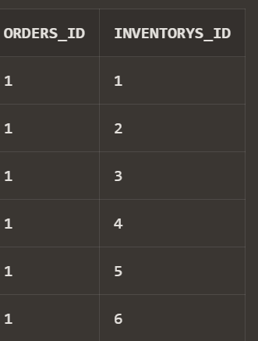

INSERT INTO items (item_id, description, category, name) VALUES (1, 'Description for Item 1', 'Category 2', 'ItemName 1');

INSERT INTO items (item_id, description, category, name) VALUES (2, 'Description for Item 2', 'Category 3', 'ItemName 2');

INSERT INTO items (item_id, description, category, name) VALUES

(3, 'Description for Item 3', 'Category 4', 'ItemName 3');

INSERT INTO items (item_id, description, category, name) VALUES (4, 'Description for Item 4', 'Category 5', 'ItemName 4');

INSERT INTO items (item_id, description, category, name) VALUES (5, 'Description for Item 5', 'Category 1', 'ItemName 5');

INSERT INTO items (item_id, description, category, name) VALUES (6, 'Description for Item 6', 'Category 2', 'ItemName 6');

INSERT INTO items (item_id, description, category, name) VALUES (7, 'Description for Item 7', 'Category 3', 'ItemName 7');

INSERT INTO items (item_id, description, category, name) VALUES (8, 'Description for Item 8', 'Category 4', 'ItemName 8');

INSERT INTO items (item_id, description, category, name) VALUES (9, 'Description for Item 9', 'Category 5', 'ItemName 9');

INSERT INTO items (item_id, description, category, name) VALUES (10, 'Description for Item 10', 'Category 1', 'ItemName 10');

INSERT INTO items (item_id, description, category, name) VALUES (11, 'Description for Item 11', 'Category 2', 'ItemName 11');

INSERT INTO items (item_id, description, category, name) VALUES

(12, 'Description for Item 12', 'Category 3', 'ItemName 12');

INSERT INTO items (item_id, description, category, name) VALUES (13, 'Description for Item 13', 'Category 4', 'ItemName 13');

INSERT INTO items (item_id, description, category, name) VALUES (14, 'Description for Item 14', 'Category 5', 'ItemName 14');

INSERT INTO items (item_id, description, category, name) VALUES (15, 'Description for Item 15', 'Category 1', 'ItemName 15');

INSERT INTO items (item_id, description, category, name) VALUES

(16, 'Description for Item 16', 'Category 2', 'ItemName 16');

INSERT INTO items (item_id, description, category, name) VALUES (17, 'Description for Item 17', 'Category 3', 'ItemName 17');

INSERT INTO items (item_id, description, category, name) VALUES (18, 'Description for Item 18', 'Category 4', 'ItemName 18');

INSERT INTO items (item_id, description, category, name) VALUES

(19, 'Description for Item 19', 'Category 5', 'ItemName 19');

INSERT INTO items (item_id, description, category, name) VALUES (20, 'Description for Item 20', 'Category 1', 'ItemName 20'); INSERT INTO items (item_id, description, category, name) VALUES (21, 'Description for Item 21', 'Category 2', 'ItemName 21');

INSERT INTO items (item_id, description, category, name) VALUES (22, 'Description for Item 22', 'Category 3', 'ItemName 22');

INSERT INTO items (item_id, description, category, name) VALUES (23, 'Description for Item 23', 'Category 4', 'ItemName 23');

INSERT INTO items (item_id, description, category, name) VALUES (24, 'Description for Item 24', 'Category 5', 'ItemName 24');

INSERT INTO items (item_id, description, category, name) VALUES (25, 'Description for Item 25', 'Category 1', 'ItemName 25');

INSERT INTO items (item_id, description, category, name) VALUES

(26, 'Description for Item 26', 'Category 2', 'ItemName 26');

INSERT INTO items (item_id, description, category, name) VALUES (27, 'Description for Item 27', 'Category 3', 'ItemName 27');

INSERT INTO items (item_id, description, category, name) VALUES (28, 'Description for Item 28', 'Category 4', 'ItemName 28');

INSERT INTO items (item_id, description, category, name) VALUES (29, 'Description for Item 29', 'Category 5', 'ItemName 29');

INSERT INTO items (item_id, description, category, name) VALUES

(30, 'Description for Item 30', 'Category 1', 'ItemName 30');

select * from items;

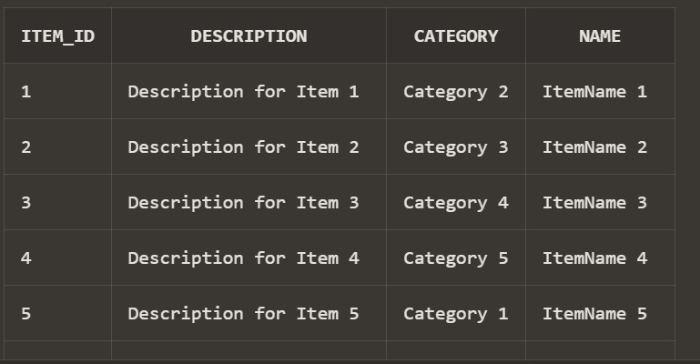

INSERT INTO hold_item (invento_id, item_id) VALUES (1, 1);

INSERT INTO hold_item (invento_id, item_id) VALUES (2, 2);

INSERT INTO hold_item (invento_id, item_id) VALUES (3, 3);

INSERT INTO hold_item (invento_id, item_id) VALUES

(4, 4);

INSERT INTO hold_item (invento_id, item_id) VALUES (5, 5);

INSERT INTO hold_item (invento_id, item_id) VALUES (6, 6);

INSERT INTO hold_item (invento_id, item_id) VALUES

(7, 7);

INSERT INTO hold_item (invento_id, item_id) VALUES (8, 8);

INSERT INTO hold_item (invento_id, item_id) VALUES

(9, 9);

INSERT INTO hold_item (invento_id, item_id) VALUES (10, 10);

INSERT INTO hold_item (invento_id, item_id) VALUES (11, 11);

INSERT INTO hold_item (invento_id, item_id) VALUES (12, 12);

INSERT INTO hold_item (invento_id, item_id) VALUES (13, 13);

INSERT INTO hold_item (invento_id, item_id) VALUES

(14, 14);

INSERT INTO hold_item (invento_id, item_id) VALUES (15, 15);

INSERT INTO hold_item (invento_id, item_id) VALUES (16, 16);

INSERT INTO hold_item (invento_id, item_id) VALUES (17, 17);

INSERT INTO hold_item (invento_id, item_id) VALUES

(18, 18);

INSERT INTO hold_item (invento_id, item_id) VALUES (19, 19);

INSERT INTO hold_item (invento_id, item_id) VALUES (20, 20);

INSERT INTO hold_item (invento_id, item_id) VALUES (21, 21);

INSERT INTO hold_item (invento_id, item_id) VALUES (22, 22);

INSERT INTO hold_item (invento_id, item_id) VALUES

(23, 23);

INSERT INTO hold_item (invento_id, item_id) VALUES (24, 24);

INSERT INTO hold_item (invento_id, item_id) VALUES (25, 25);

INSERT INTO hold_item (invento_id, item_id) VALUES (26, 26);

INSERT INTO hold_item (invento_id, item_id) VALUES

(27, 27);

INSERT INTO hold_item (invento_id, item_id) VALUES (28, 28);

INSERT INTO hold_item (invento_id, item_id) VALUES (29, 29);

INSERT INTO hold_item (invento_id, item_id) VALUES

(30, 30);

INSERT INTO hold_item (invento_id, item_id) VALUES

select * from hold_item;

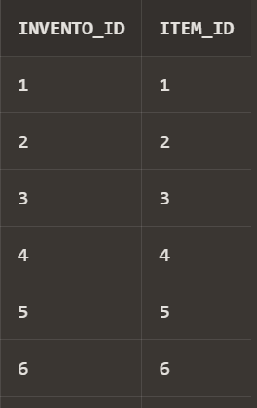

INSERT INTO shipment (shipment_id, ship_date, transport_method, destination) VALUES (1, TO_DATE('2024-03-27', 'YYYY-MM-DD'), 'Truck',

'Destination A');

INSERT INTO shipment (shipment_id, ship_date, transport_method, destination) VALUES (2, TO_DATE('2024-03-28', 'YYYY-MM-DD'), 'Ship',

'Destination B');

INSERT INTO shipment (shipment_id, ship_date, transport_method, destination) VALUES (3, TO_DATE('2024-03-29', 'YYYY-MM-DD'), 'Plane',

'Destination C');

INSERT INTO shipment (shipment_id, ship_date, transport_method, destination) VALUES (4, TO_DATE('2024-03-30', 'YYYY-MM-DD'), 'Train',

'Destination D');

INSERT INTO shipment (shipment_id, ship_date, transport_method, destination) VALUES (5, TO_DATE('2024-03-31', 'YYYY-MM-DD'), 'Truck',

'Destination E');

INSERT INTO shipment (shipment_id, ship_date, transport_method, destination) VALUES (6, TO_DATE('2024-04-01', 'YYYY-MM-DD'), 'Ship',

'Destination F');

INSERT INTO shipment (shipment_id, ship_date, transport_method, destination) VALUES (7, TO_DATE('2024-04-02', 'YYYY-MM-DD'), 'Plane',

'Destination G');

INSERT INTO shipment (shipment_id, ship_date, transport_method, destination) VALUES (8, TO_DATE('2024-04-03', 'YYYY-MM-DD'), 'Train',

'Destination H');

INSERT INTO shipment (shipment_id, ship_date, transport_method, destination) VALUES (9, TO_DATE('2024-04-04', 'YYYY-MM-DD'), 'Truck',

'Destination I');

INSERT INTO shipment (shipment_id, ship_date, transport_method, destination) VALUES (10, TO_DATE('2024-04-05', 'YYYY-MM-DD'), 'Ship',

'Destination J');

INSERT INTO shipment (shipment_id, ship_date, transport_method, destination) VALUES (11, TO_DATE('2024-04-06', 'YYYY-MM-DD'), 'Plane',

'Destination K');

INSERT INTO shipment (shipment_id, ship_date, transport_method, destination) VALUES (12, TO_DATE('2024-04-07', 'YYYY-MM-DD'), 'Train',

'Destination L');

INSERT INTO shipment (shipment_id, ship_date, transport_method, destination) VALUES (13, TO_DATE('2024-04-08', 'YYYY-MM-DD'), 'Truck',

'Destination M');

INSERT INTO shipment (shipment_id, ship_date, transport_method, destination) VALUES (14, TO_DATE('2024-04-09', 'YYYY-MM-DD'), 'Ship',

'Destination N');

INSERT INTO shipment (shipment_id, ship_date, transport_method, destination) VALUES (15, TO_DATE('2024-04-10', 'YYYY-MM-DD'), 'Plane',

'Destination O');

INSERT INTO shipment (shipment_id, ship_date, transport_method, destination) VALUES (16, TO_DATE('2024-04-11', 'YYYY-MM-DD'), 'Train',

'Destination P');

INSERT INTO shipment (shipment_id, ship_date, transport_method, destination) VALUES (17, TO_DATE('2024-04-12', 'YYYY-MM-DD'), 'Truck',

'Destination Q');

INSERT INTO shipment (shipment_id, ship_date, transport_method, destination) VALUES (18, TO_DATE('2024-04-13', 'YYYY-MM-DD'), 'Ship',

'Destination R');

INSERT INTO shipment (shipment_id, ship_date, transport_method, destination) VALUES (19, TO_DATE('2024-04-14', 'YYYY-MM-DD'), 'Plane',

'Destination S');

INSERT INTO shipment (shipment_id, ship_date, transport_method, destination) VALUES (20, TO_DATE('2024-04-15', 'YYYY-MM-DD'), 'Train',

'Destination T');

INSERT INTO shipment (shipment_id, ship_date, transport_method, destination) VALUES (21, TO_DATE('2024-04-16', 'YYYY-MM-DD'), 'Truck',

'Destination U');

INSERT INTO shipment (shipment_id, ship_date, transport_method, destination) VALUES (22, TO_DATE('2024-04-17', 'YYYY-MM-DD'), 'Ship',

'Destination V');

INSERT INTO shipment (shipment_id, ship_date, transport_method, destination) VALUES (23, TO_DATE('2024-04-18', 'YYYY-MM-DD'), 'Plane',

'Destination W');

INSERT INTO shipment (shipment_id, ship_date, transport_method, destination) VALUES (24, TO_DATE('2024-04-19', 'YYYY-MM-DD'), 'Train',

'Destination X');

INSERT INTO shipment (shipment_id, ship_date, transport_method, destination) VALUES (25, TO_DATE('2024-04-20', 'YYYY-MM-DD'), 'Truck',

'Destination Y');

INSERT INTO shipment (shipment_id, ship_date, transport_method, destination) VALUES (26, TO_DATE('2024-04-21', 'YYYY-MM-DD'), 'Ship',

'Destination Z');

INSERT INTO shipment (shipment_id, ship_date, transport_method, destination) VALUES (27, TO_DATE('2024-04-22', 'YYYY-MM-DD'), 'Plane',

'Destination AA');

INSERT INTO shipment (shipment_id, ship_date, transport_method, destination) VALUES (28, TO_DATE('2024-04-23', 'YYYY-MM-DD'), 'Train',

'Destination AB');

INSERT INTO shipment (shipment_id, ship_date, transport_method, destination) VALUES (29, TO_DATE('2024-04-24', 'YYYY-MM-DD'), 'Truck',

'Destination AC');

INSERT INTO shipment (shipment_id, ship_date, transport_method, destination) VALUES (30, TO_DATE('2024-04-25', 'YYYY-MM-DD'), 'Ship',

'Destination AD');

select * from shipment

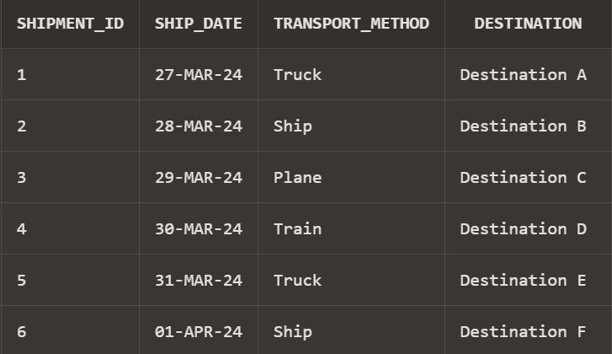

INSERT INTO shipment_item (shipment_item_id, invent_id, shipment_id) VALUES (1, 1, 1);

INSERT INTO shipment_item (shipment_item_id, invent_id, shipment_id)

VALUES (2, 2, 1);

INSERT INTO shipment_item (shipment_item_id, invent_id, shipment_id) VALUES (3, 3, 1);

INSERT INTO shipment_item (shipment_item_id, invent_id, shipment_id) VALUES (4, 4, 1);

INSERT INTO shipment_item (shipment_item_id, invent_id, shipment_id) VALUES (5, 5, 1);

-- Assume continuation for brevity

INSERT INTO shipment_item (shipment_item_id, invent_id, shipment_id) VALUES (896, 26, 30);

INSERT INTO shipment_item (shipment_item_id, invent_id, shipment_id) VALUES (897, 27, 30);

INSERT INTO shipment_item (shipment_item_id, invent_id, shipment_id) VALUES (898, 28, 30);

INSERT INTO shipment_item (shipment_item_id, invent_id, shipment_id) VALUES (899, 29, 30);

INSERT INTO shipment_item (shipment_item_id, invent_id, shipment_id) VALUES (900, 30, 30);

select * from shipment_item;

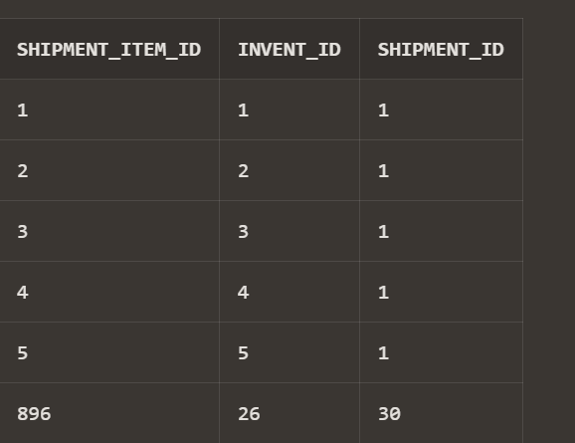

## Find all raw materials provided by a speciflc supplier, identifled by name:

SELECT rm.material_id, rm.unit_price, rm.quantity FROM raw_materials rm

JOIN suppliers s ON rm.supplier_id = s.supplier_id WHERE s.name = 'Supplier A1';

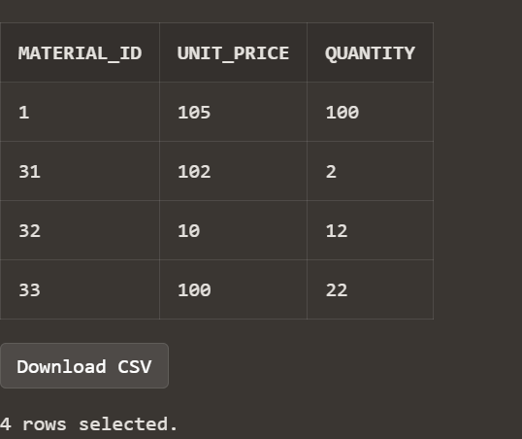

## Calculate the total price of all orders from a speciflc supplier:

SELECT o.suppliers_id, SUM(o.total_price) AS total_spent FROM orders o

WHERE o.suppliers_id = (SELECT supplier_id FROM suppliers WHERE name = 'Supplier A1')

GROUP BY o.suppliers_id;

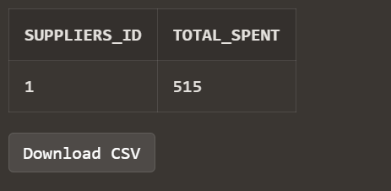

## Insert a new supplier into the suppliers table:

INSERT INTO suppliers (supplier_id, name, email, phone_no) VALUES (31, 'New Supplier', ['new@example.com',](mailto:%27new@example.com) 1112223334);

select * from suppliers where supplier_id=31;

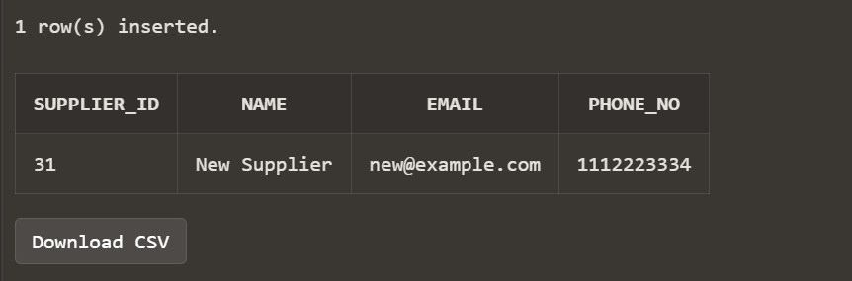

## Update the quantity of a speciflc raw material:

UPDATE raw_materials SET quantity = 100

WHERE material_id = 1 AND supplier_id = 1;

select * from raw_materials where material_id=1;

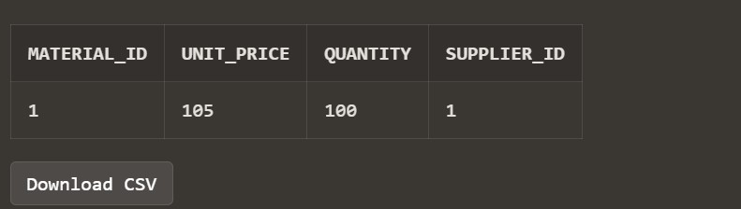

## Find all orders along with the supplier name:

SELECT o.order_id, o.order_date, o.total_price, s.name AS supplier_name FROM orders o

JOIN suppliers s ON o.suppliers_id = s.supplier_id;

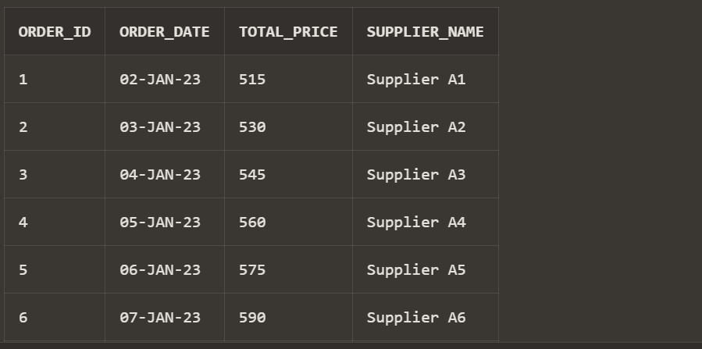

## List inventory items stored in a speciflc city:

SELECT i.item_name, i.quantity, st.city_name FROM inventory i

JOIN storage st ON i.storage_id = st.storage_id WHERE st.city_name = 'City 1';

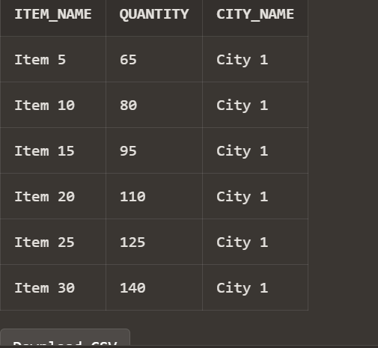

## Find the total quantity of items ordered by each order:

SELECT o.order_id, SUM(i.quantity) AS total_items FROM orders o

JOIN contains_items_in ci ON o.order_id = ci.orders_id

JOIN inventory i ON ci.inventorys_id = i.inventory_id GROUP BY o.order_id;

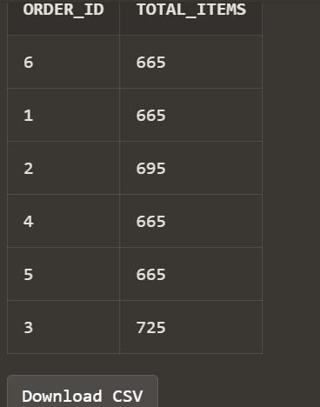

## Delete a supplier from the database:

DELETE FROM suppliers WHERE supplier_id = 31;

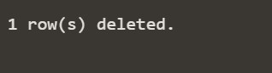

## Show shipments planned for a speciflc destination:

SELECT shipment_id, ship_date, transport_method FROM shipment

WHERE destination = 'Destination A';

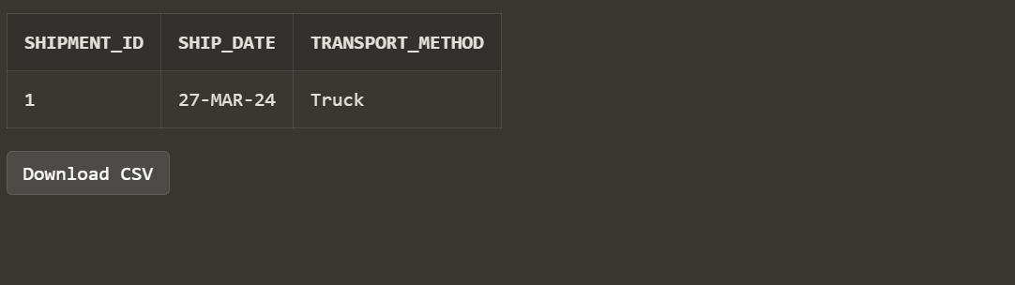

## List all orders, including item names and quantities, for each supplier:

SELECT s.supplier_id, s.name AS supplier_name, o.order_id, i.item_name, SUM(i.quantity) AS total_quantity

FROM suppliers s

JOIN orders o ON s.supplier_id = o.suppliers_id

JOIN contains_items_in ciin ON o.order_id = ciin.orders_id JOIN inventory i ON ciin.inventorys_id = i.inventory_id GROUP BY s.supplier_id, s.name, o.order_id, i.item_name ORDER BY s.supplier_id, o.order_id;

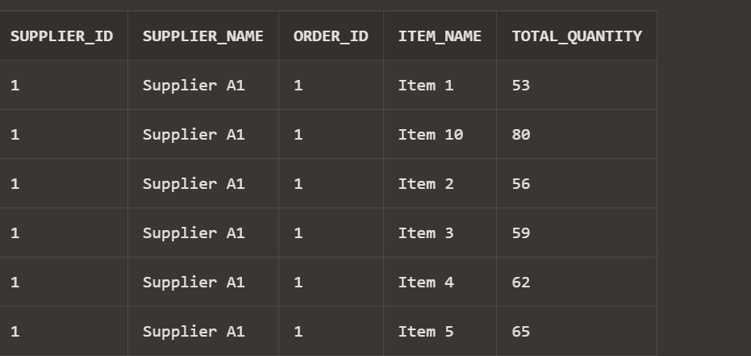

## Rank suppliers based on the total price of orders:

SELECT s.supplier_id, s.name, SUM(o.total_price) OVER (PARTITION BY s.supplier_id) AS total_spent,

RANK() OVER (ORDER BY SUM(o.total_price) DESC) AS spending_rank FROM suppliers s

JOIN orders o ON s.supplier_id = o.suppliers_id GROUP BY s.supplier_id, s.name, o.total_price ORDER BY total_spent DESC;

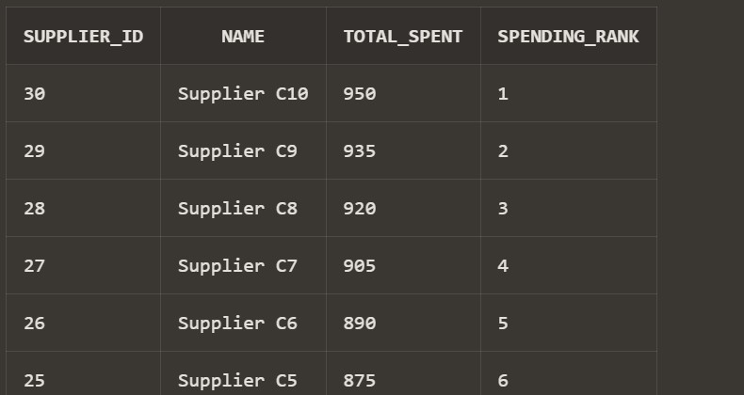

## Find the top 3 most stocked items in each storage facility:

WITH RankedItems AS (

SELECT storage_id, item_name, quantity, RANK() OVER (PARTITION BY storage_id ORDER BY quantity DESC) AS rank

FROM inventory

)

SELECT storage_id, item_name, quantity, rank FROM RankedItems

WHERE rank <= 3;

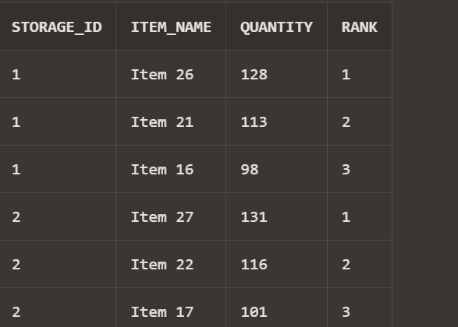

## Calculate the average unit price of raw materials supplied by each supplier:

SELECT s.name AS supplier_name, AVG(rm.unit_price) AS avg_unit_price FROM raw_materials rm

JOIN suppliers s ON rm.supplier_id = s.supplier_id GROUP BY s.name;

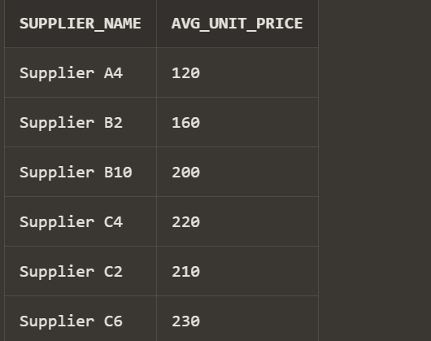

## List shipments that include items from more than one storage location:

WITH ShipmentDetails AS (

SELECT sh.shipment_id, inv.storage_id FROM shipment sh

JOIN shipment_item si ON sh.shipment_id = si.shipment_id JOIN inventory inv ON si.invent_id = inv.inventory_id

GROUP BY sh.shipment_id, inv.storage_id

)

SELECT shipment_id FROM ShipmentDetails GROUP BY shipment_id

HAVING COUNT(DISTINCT storage_id) > 1;

